2020BTECS00106

Batch – T8

Software Engineering Tools Lab

Assignment No. 1

1. Differentiate in between free software, Open source software and proprietary software with respect to its properties.

Free Software: “Free software” means software that respects users’ freedom and community. Roughly, it means that the users have the freedom to run, copy, distribute, study, change and improve the software. The term “free software” is sometimes misunderstood—it has nothing to do with price. It is about freedom.

Open Source Software: Open Source Software is something that you can modify as per your needs, and share with others without any licensing violation burden. When we say Open Source, the source code of the software is available publicly with Open Source licenses like GNU (GPL) which allows you to edit the source code and distribute it. Read these licenses and you will realize that these licenses are created to help us.

Coined by the development environments around software produced by open collaboration of software developers on the internet.

Later specified by the Open Source Initiative (OSI).

It does not explicitly state ethical values, besides those directly associated with software development.

1. Open source Software: Open source software is computer software whose source code is available openly on the internet and programmers can modify it to add new features and capabilities without any cost. Here the software is developed and tested through open collaboration. This software is managed by an open-source community of developers. It provides community support, as well as commercial support, which is available for maintenance. We can get it for free of cost. This software also sometimes comes with a license and sometimes does not. This license provides some rights to users.

The software can be used for any purpose

Allows to study how the software works

Freedom to modify and improve the program

No restrictions on redistribution

Some examples of Open source software include Android, Ubuntu, Firefox, Open Office, etc.

2. Proprietary Software: Proprietary software is computer software where the source codes are publicly not available only the company that has created them can modify it. Here the software is developed and tested by the individual or organization by which it is owned not by the public. This software is managed by a closed team of individuals or groups that developed it. We have to pay to get this software and its commercial support is available for maintenance. The company gives a valid and authenticated license to the users to use this software. But this license puts some restrictions on users also like.

Number of installations of this software into computers

Restrictions on sharing of software illegally

Time period up to which software will operate

Number of features allowed to use

Some examples of Proprietary software include Windows, macOS, Internet Explorer, Google Earth, Microsoft Office, etc.

**Difference between Open-source Software and Proprietary Software:**

| S.No. | OPEN-SOURCE SOFTWARE | PROPRIETARY SOFTWARE |
| --- | --- | --- |
| 01. | Open-source software is computer software whose source code is available openly on the internet and programmers can modify it to add new features and capabilities without any cost. | Proprietary software is computer software where the source codes are publicly not available only the company which has created can modify it. |
| 02. | Here the software is developed and tested through open collaboration. | Here the software is developed and tested by the individual or organization by which it is owned not by the public. |
| 03. | In open-source software the source code is public. | In proprietary software, the source code is protected. |
| 04. | Open-source software can be installed on any computer. | Proprietary software can not be installed into any computer without a valid license. |
| 05. | Users do not need to have any authenticated license to use this software. | Users need to have a valid and authenticated license to use this software. |
| 06. | Open-source software is managed by an open-source community of developers. | Proprietary software is managed by a closed team of individuals or groups that developed it. |
| 07. | It is more flexible and provides more freedom which encourages innovation. | It is not much flexible so there is a very limited innovation scope with the restrictions. |
| 08. | Users can get open software free of charge. | Users must have to pay to get the proprietary software. |
| 09. | In open-source software faster fixes of bugs and better security are availed due to the community. | In proprietary software, the vendor is completely responsible for fixing malfunctions. |
| 10. | Limited Intellectual Property Protections | Full Intellectual Property Protections |
| 11. | Usually Developed and Maintained by non-profit organizations. | Usually Developed and Maintained by for-profit entities. |
| 12. | Examples are Android, Linux, Firefox, Open Office, GIMP, VLC Media player, etc. | Examples are Windows, macOS, Internet Explorer, Google Earth, Microsoft Office, Adobe Flash Player, Skype, etc. |

**Difference between Free Software and Open Source Software:**

| S.No. | FS Philosophy | OSS Philosophy |
| --- | --- | --- |
| 1. | It was coined by the Free Software Foundation in the 1980s. | In response to the restrictions of free software, the phrase “open source” was coined in the late 1990s. |
| 2. | Software is an important part of people’s lives. | Software is just software. There are no ethics associated directly with it. |
| 3. | Software freedom translates to social freedom. | Ethics are to be associated with the people not with the software. |
| 4. | Freedom is a value that is more important than any economical advantage. | Freedom is not an absolute concept. Freedom should be allowed, not imposed. |
| 5. | Every free software is open source. | Every open-source software is not free software. |
| 6. | There is no such issue that exists in free software. | There are many different open-source software licenses, and some of them are quite restricted, resulting in open-source software that is not free. |
| 7. | No restrictions are imposed on free software. | Open-source software occasionally imposes some constraints on users. |
| 8. | Examples: The Free Software Directory maintains a large database of free software packages. Some of the best-known examples include the Linux kernel, the BSD and Linux operating systems, the GNU Compiler Collection and C library; the MySQL relational database; the Apache web server; and the Sendmail mail transport agent. | Examples: Prime examples of open-source products are the Apache HTTP Server, the e-commerce platform Open Source Commerce, internet browsers Mozilla Firefox, and Chromium (the project where the vast majority of development of the freeware Google Chrome is done), and the full office suite LibreOffice. |

2. Enlist some examples along with its purpose and properties (at least 10) of FOSS and

proprietary software with respect to database.

1) MySQL (FOSS) - a popular open-source relational database management system

used for web applications and data warehousing. Purpose: to provide a fast, reliable,

and easy-to-use database system. Properties: supports multiple storage engines,

has a large community of users and developers, and is available under the GNU

General Public License.

2) PostgreSQL (FOSS) - an object-relational database management system that

emphasizes extensibility and SQL compliance. Purpose: to provide a powerful and

flexible open-source alternative to commercial databases. Properties: supports

advanced data types and indexing methods, has strong community support, and is

available under the PostgreSQL License.

3) MongoDB (FOSS) - a popular open-source document-oriented NoSQL database that

is widely used for big data and real-time web applications. Purpose: to provide a

high-performance and scalable database system that can handle unstructured data.

Properties: supports horizontal scaling, high availability, and rich query language, and

is available under the Server Side Public License.

4) Oracle Database (Proprietary) - a widely used commercial relational database

management system that is known for its advanced features and scalability. Purpose:

to provide enterprise-level performance and security for mission-critical applications.

Properties: supports advanced data warehousing and business intelligence features,

has strong support for big data and cloud computing, and is available under a

commercial license.

5) Microsoft SQL Server (Proprietary) - a popular commercial relational database

management system that is widely used for Windows-based applications. Purpose:

to provide a high-performance and secure database system for businesses of all

sizes. Properties: supports advanced data warehousing and business intelligence

features, has strong integration with other Microsoft products, and is available under

a commercial license.

6) SQLite (FOSS) - a self-contained, serverless, zero-configuration, transactional SQL

database engine that is widely used in embedded systems and mobile devices.

Purpose: to provide a lightweight and simple-to-use database system that can be

easily embedded into other applications. Properties: supports ACID transactions, has

a small footprint, and is available under the Public Domain.

7) Redis (FOSS) - an open-source in-memory data structure store that is widely used as

a database, cache, and message broker. Purpose: to provide a high-performance

and scalable data store that can handle real-time data. Properties: supports

advanced data structures, has strong community support, and is available under the

BSD 3-Clause license.

8) Firebase Realtime Database (Proprietary) - a cloud-hosted NoSQL database that is

widely used for mobile and web applications. Purpose: to provide a simple-to-use

and scalable database system that can handle real-time data. Properties: supports

real-time data synchronization, has built-in security and authentication features, and

is available under a commercial license.

9) Cassandra (FOSS) - a highly-scalable and distributed NoSQL database that is widely

used for big data and real-time web applications. Purpose: to provide a

high-performance and fault-tolerant database system that can handle large amounts

of data. Properties: supports horizontal scaling, high availability, and tunable

consistency, and is available under the Apache License 2.0.

10) RethinkDB (FOSS) - an open-source distributed NoSQL database that is widely used

for real-time web applications and real-time analytics. Purpose: to provide a powerful

and flexible database system that can handle real-time data. Properties: supports

real-time data feeds, has a rich

3. Enlist some examples of free open source exam software for online assessment.

**11 Free Open Source Exam Software List for Online Assessment**

* [TCExam](https://www.techjockey.com/blog/7-free-open-source-exam-software#tcexam)
* [VirtualX](https://www.techjockey.com/blog/7-free-open-source-exam-software#virtualx)
* [Moodle](https://www.techjockey.com/blog/7-free-open-source-exam-software#moodle)
* [TAO](https://www.techjockey.com/blog/7-free-open-source-exam-software#tao)
* [Kaldin](https://www.techjockey.com/blog/7-free-open-source-exam-software#Kaldin)
* [Papershala](https://www.techjockey.com/blog/7-free-open-source-exam-software#papershala)
* [Edbase](https://www.techjockey.com/blog/7-free-open-source-exam-software#edbase)
* [Mettl](https://www.techjockey.com/blog/7-free-open-source-exam-software#mettl)
* [FlexiQuiz](https://www.techjockey.com/blog/7-free-open-source-exam-software#flexiquiz)
* [Eklavvya](https://www.techjockey.com/blog/7-free-open-source-exam-software#eklavya)
* [Think Exam](https://www.techjockey.com/blog/7-free-open-source-exam-software#think_exam)

4. Demonstrate any one exam software which is open source and freely available.

Software used – Flexquiz

Quiz is created and shared link to students.

Responses can be seen as anyone attempts to give test.

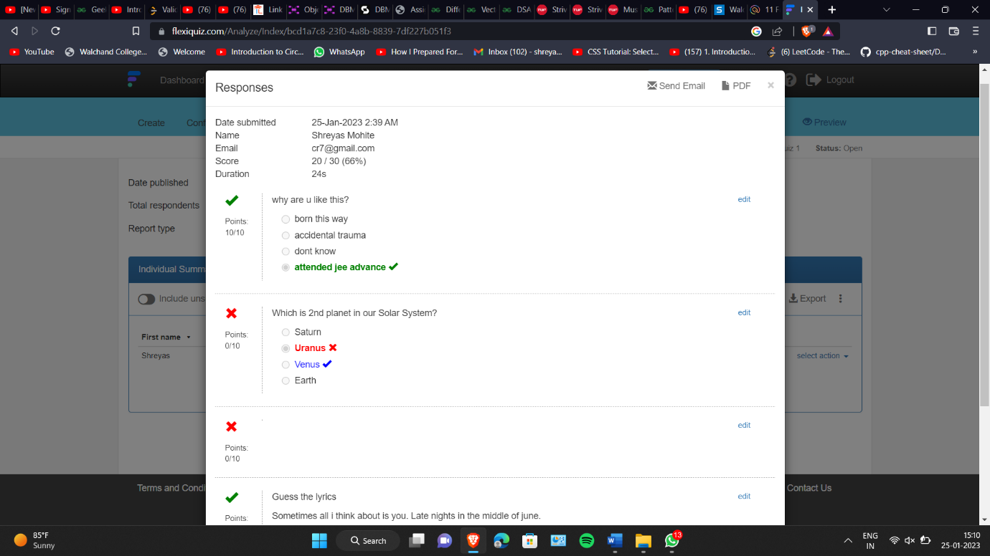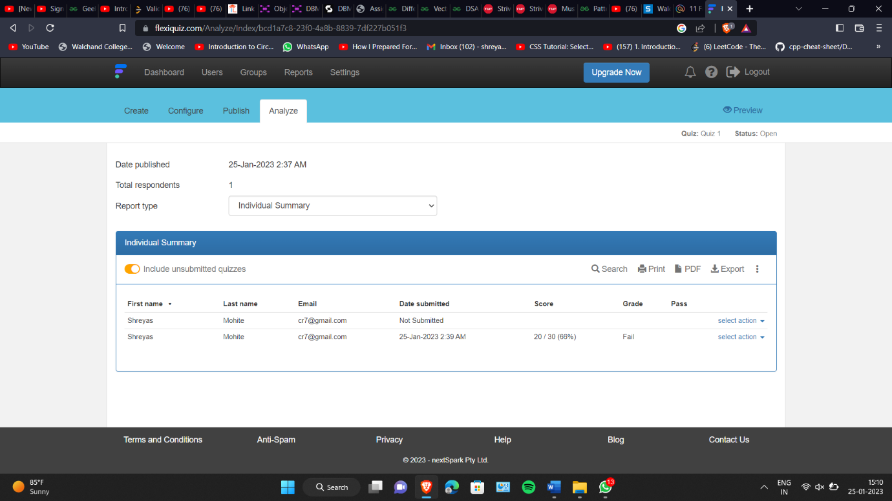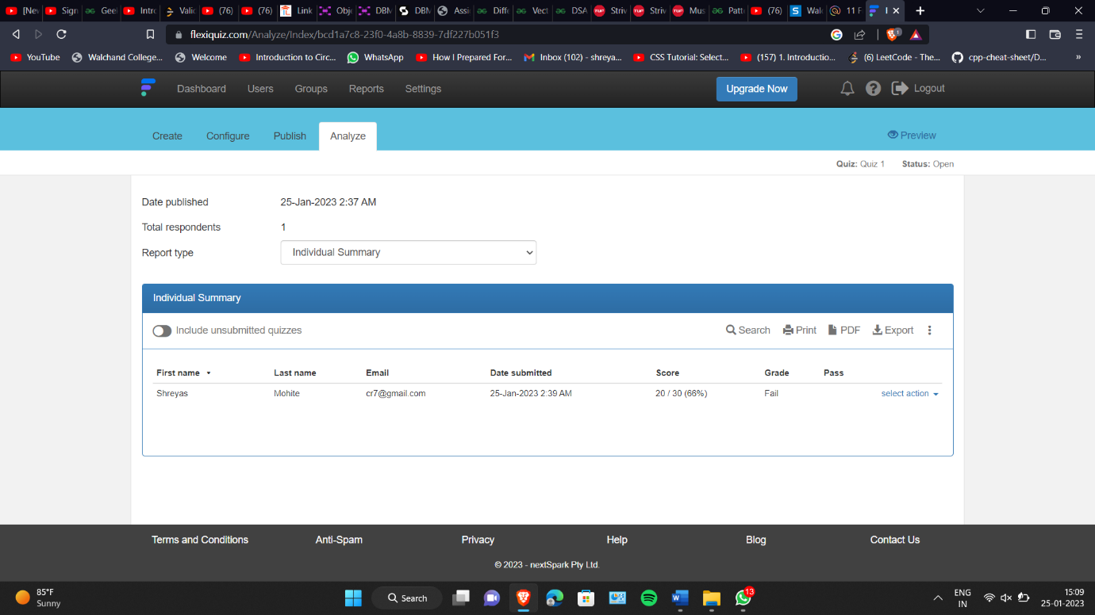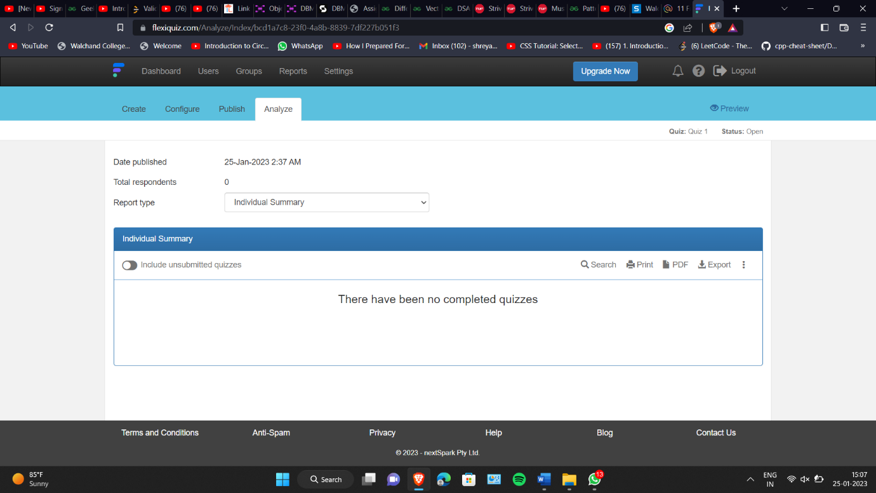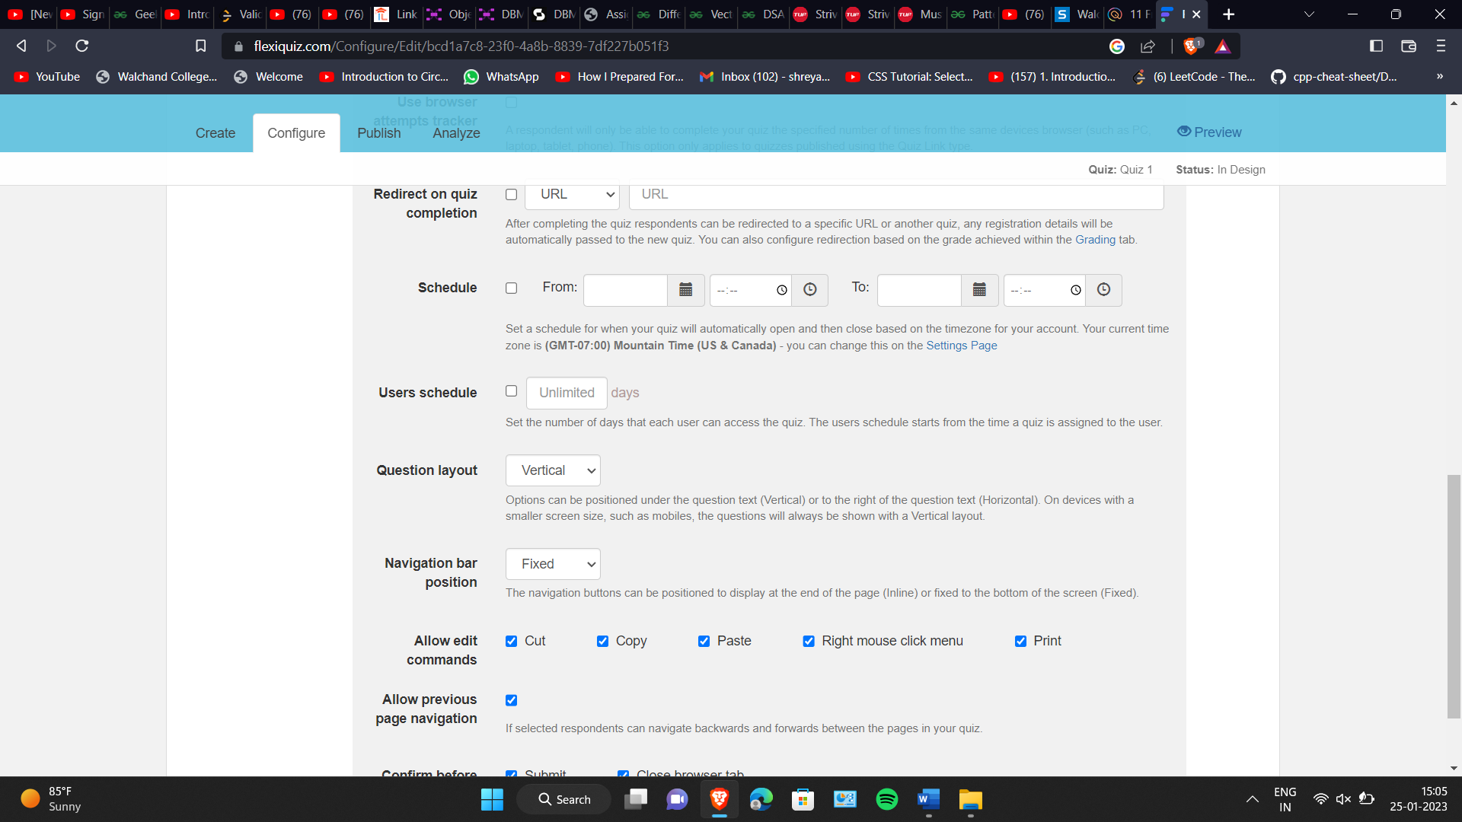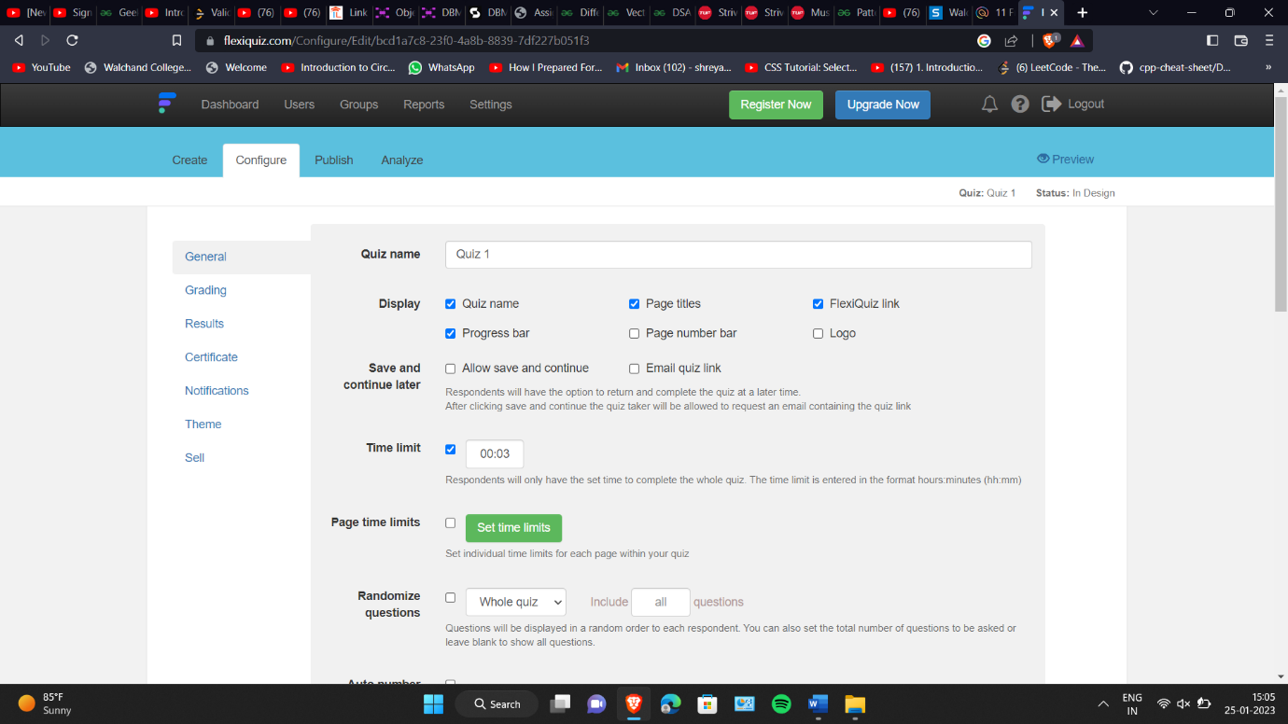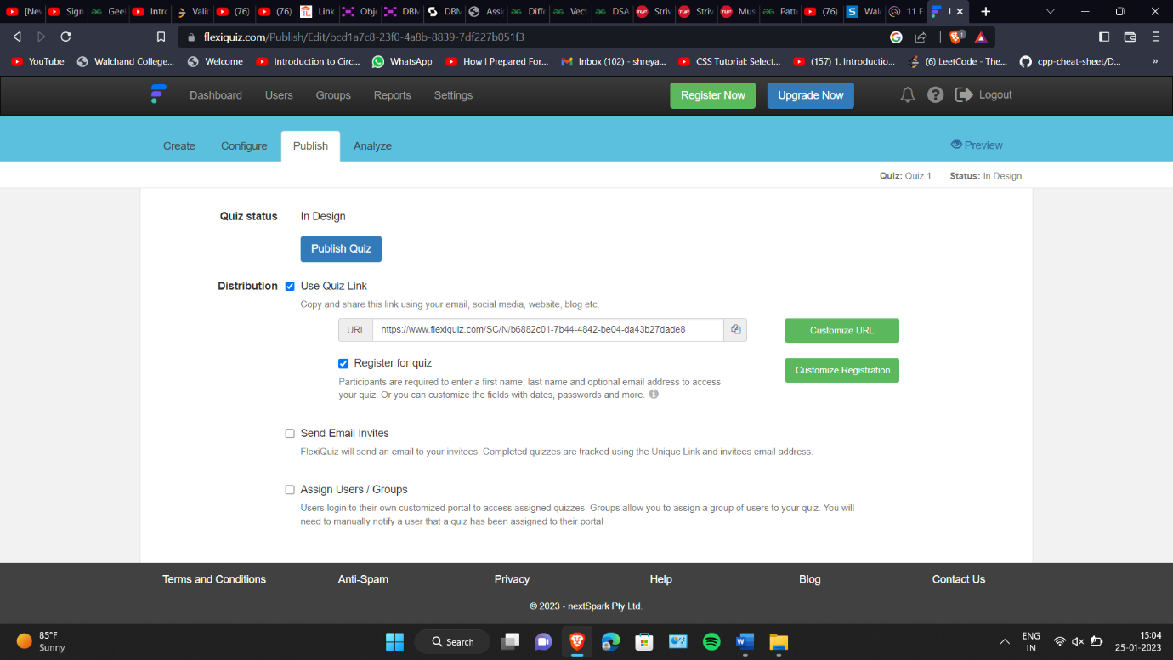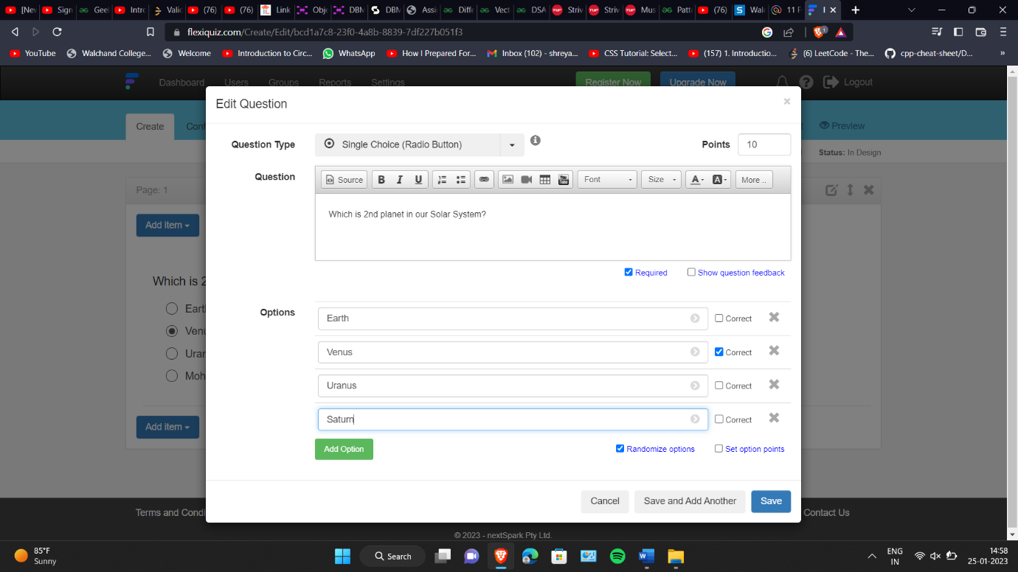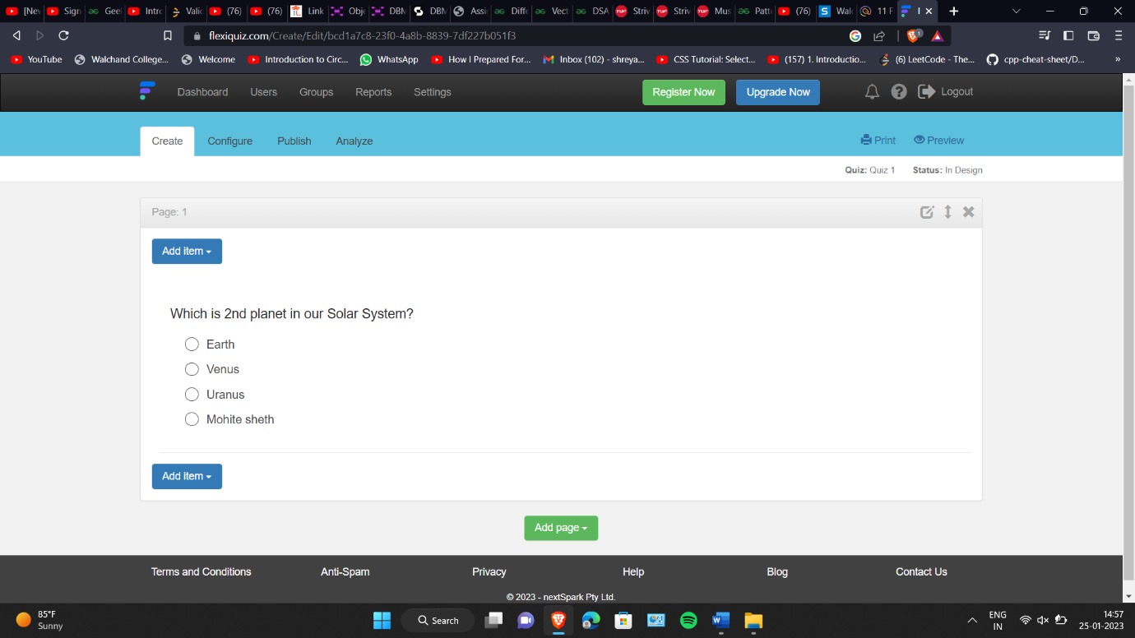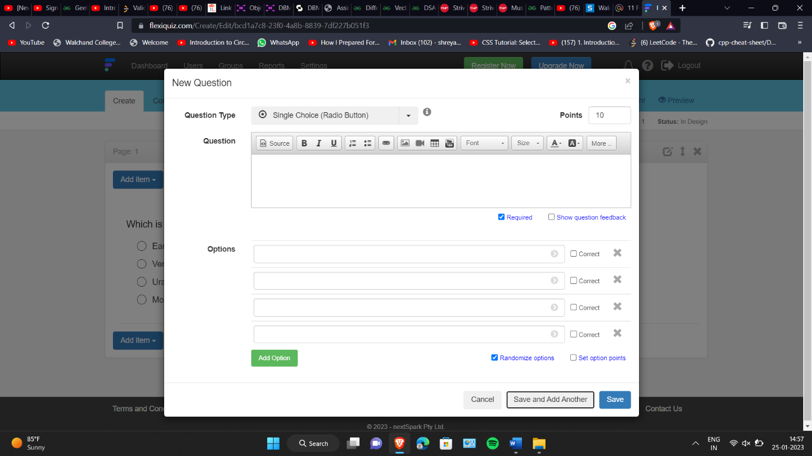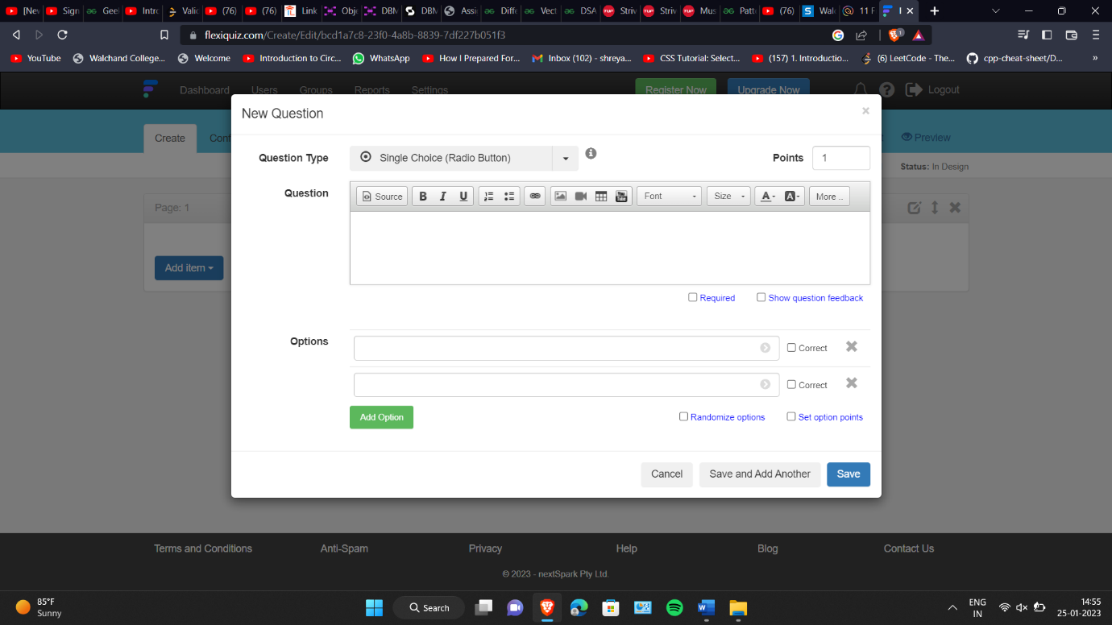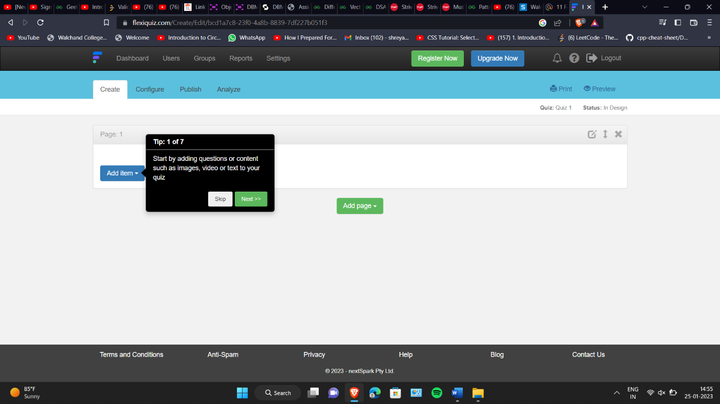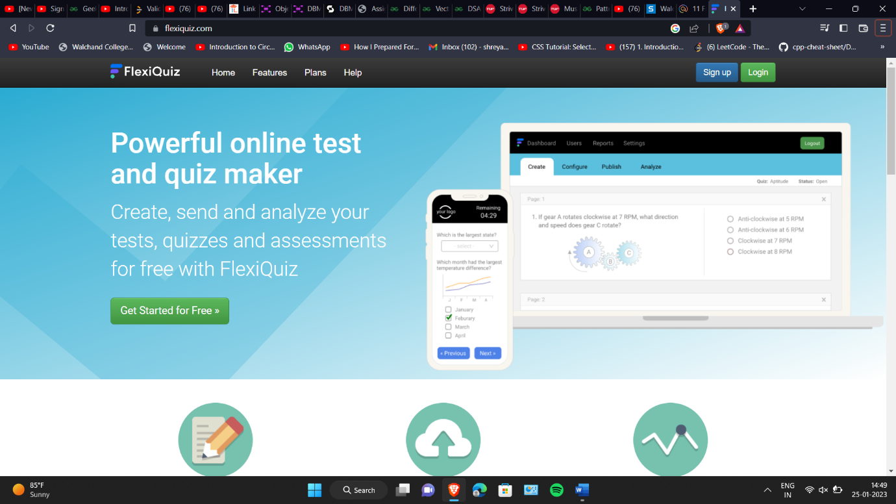

5. Demonstrate FOSS software related to database.

An open source database is any database application with a codebase that is free to view, download, modify, distribute, and reuse. Open source licenses give developers the freedom to build new applications using existing database technologies.

Open source database management systems provide a layer of abstraction developers can use to store information for organizations and their applications.

Databases are typically categorized into two groups:

* Relational databases: The traditional data storage approach in which key-value pairs are used to store structured data into tables consisting of columns and rows.
* NoSQL (non-relational) databases: Data stored using alternative data storage architectures, including document data store, column-oriented database, key-value store, and graph databases. Non-relational databases are the preferred choice for handling unstructured data.

Database management systems give you the software layer you need to control and manage your data for a multitude of purposes. For example, you can store business intelligence in a relational database for fast SQL queries or save unstructured image files in a graph database for an AI-powered analytics app.

**Closed source vs. open source databases**

Closed source databases are proprietary software. The source code cannot be accessed, modified, distributed, or reused. You may have to pay a subscription or licensing fees to use the database within your applications. The company that wrote the code maintains the codebase. That means you’ll have to wait for the company to add new features or address any bugs in the database management system.

In contrast, anyone can view and access the source code for open source databases. There are no licensing fees so the total cost of ownership (TCO) is lower for open source databases than for commercial databases. You can download and modify source code to power your apps free of charge and without vendor lock-in. On the flip side, though, you’re responsible for maintaining and securing your implementation of the open source database.

**Examples of open source databases**

Whether your goal is to store structured data for SQL queries or unstructured data via JSON objects, there are plenty of open source database solutions to choose from on the web.

Examples of commonly used open source relational databases include:

* MySQL
* PostgreSQL
* MariaDB

Examples of commonly used open source NoSQL databases include:

* MongoDB
* CouchDB
* Cassandra

**How to choose the right open source database for your needs**

There are several ways to choose the right database for your needs. You can analyze documentation or contact the company if documentation isn’t available publicly yet. You can also use online forums and blogs as well as the source code to help you determine which open source database may be a good fit for you.

To meet the objectives of database management, organisations need to:

* Optimise data warehouses
* Leverage cloud (distributed) computing
* Include graph databases
* Consider multidimensional database management systems (MDBMS)
* Provide AI frameworks
* Augment data management

Figure 1 lists the best free and open source database management systems and their type.

|  |  |  |
| --- | --- | --- |
| **S. No.** | **Database Name** | **Type** |
| 1 | PostgreSQL | Object-Relational Database Management System |
| 2 | MariaDB | Relational Database Management System |
| 3 | CockroachDB | Relational Database Management System |
| 4 | Neo4j | Graph Database Management System |
| 5 | CoughDB | NoSQL Database Management System |
| 6 | RethinkDB | Distributed Document-oriented Database Management |
| 7 | Redis | NoSQL Database Management System |
| 8 | SQLite | Relational Database Management System |
| 9 | Cassandra | NoSQL Database Management System |
| 10 | Timescale | NoSQL Database Management System |

Comparison :

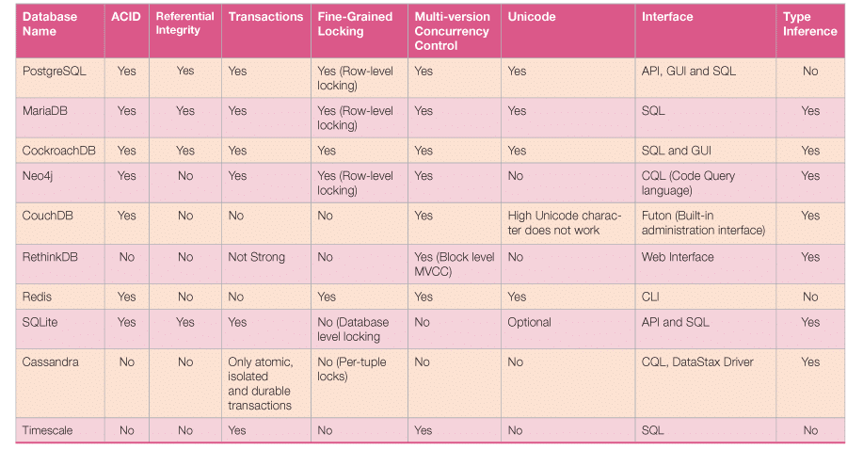

6. How does the Exam software work?

## **What are Online Proctored Exams?**

In case you don’t know, proctored exams are timed exams that you take while proctoring software monitors your computer’s desktop along with webcam video and audio. The data recorded by the proctoring software is transferred to a proctoring service for review. Proctored exams may or may not be required for your course and enrolment track.

So essentially, an online proctored exam is like any other exam but with an online infrastructure to support all the associated activities. And most importantly, invigilation, in order to maintain the sanctity of the exam room.

## **Online Proctored Exam Software: How do they work?**

Now that we know what exactly online proctored exams mean, let’s see how it works.

If you read the headline, you will notice the word “software”. A reliable, robust, and dynamic software is at the heart of any online proctoring.

Usually, the whole infrastructure is driven by a cloud-based system. Although some old organizations still rely on age-old legacy systems, it’s almost unimaginable to see how online proctoring will work without a cloud-based system given the rise of e-learning across the globe.

### Authentication of the Candidate

Like offline proctoring, online proctoring also begins with authentication. The online proctoring software checks the examinee’s authenticity and eliminates suspicious behavior during the exam.

Even before the exam starts, the software ensures that the candidate is sharing a screen with video and audio recording. Impersonation is also improbable. The online proctoring system usually requires students to present their photo IDs at the beginning of every test. Only after proctors have authenticated their identities that the test commences.

### Real-time monitoring of Candidates

Then the next step involves monitoring candidates while they are taking the exam. Usually, an algorithm consistently monitors candidates to flag any doubtful case. For instance, our own software [Dr. Proctor](https://examonline.in/solutions/remote-proctoring" \t "_blank) is driven by an AI-algorithm which can flag cases including but not limited to incidences in which a candidate is not appearing on the screen or if a mobile phone is detected, or even unusual movement of the eye or any additional person in the room.

### Data Storage and Review

Although the flag raised is real-time, the audio and video recording data of the exams are stored on the cloud. So, after the exams are over, you or your team can review the cases again.